Party reference Guide

Justice of the Peace Court MeDEation System

Table of Contents
Registering and Logging in to the System (Landlord/Tenant Matter) 4
Registering and Logging in to the System (Debt Action) 13
System Dashboard 28
Using Conversations 30
Adding another Person to your Party 32
Requesting a Mediator to Assist 34
Completing the Stipulated Agreement 35
Submitting the Stipulated Agreement to the Court 45
Appendices 46
Stipulated Agreement Example (double click to open full document) 46
Contact Information 47
Updating Account Information 47

Registering and Logging in to the System (Landlord/Tenant Matter)

When a case is added to the system, the party will receive an email (if email was provided at time case was filed) like the one below instructing the party to register, login and create a personal password. If email was not provided, parties can use their assigned case number to register on the website at https://cii2.courtinnovations.com/DEJPCOURT/court

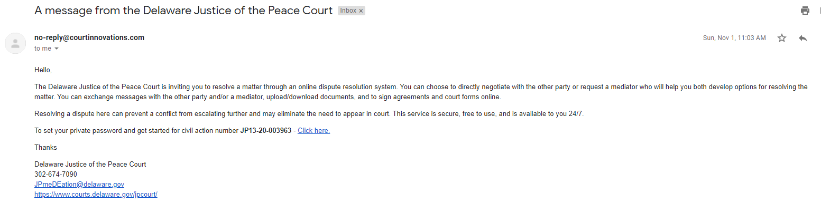

The party will reference the court notice and input their Civil Action Number (case number) in the search box located on the home screen and press SEARCH

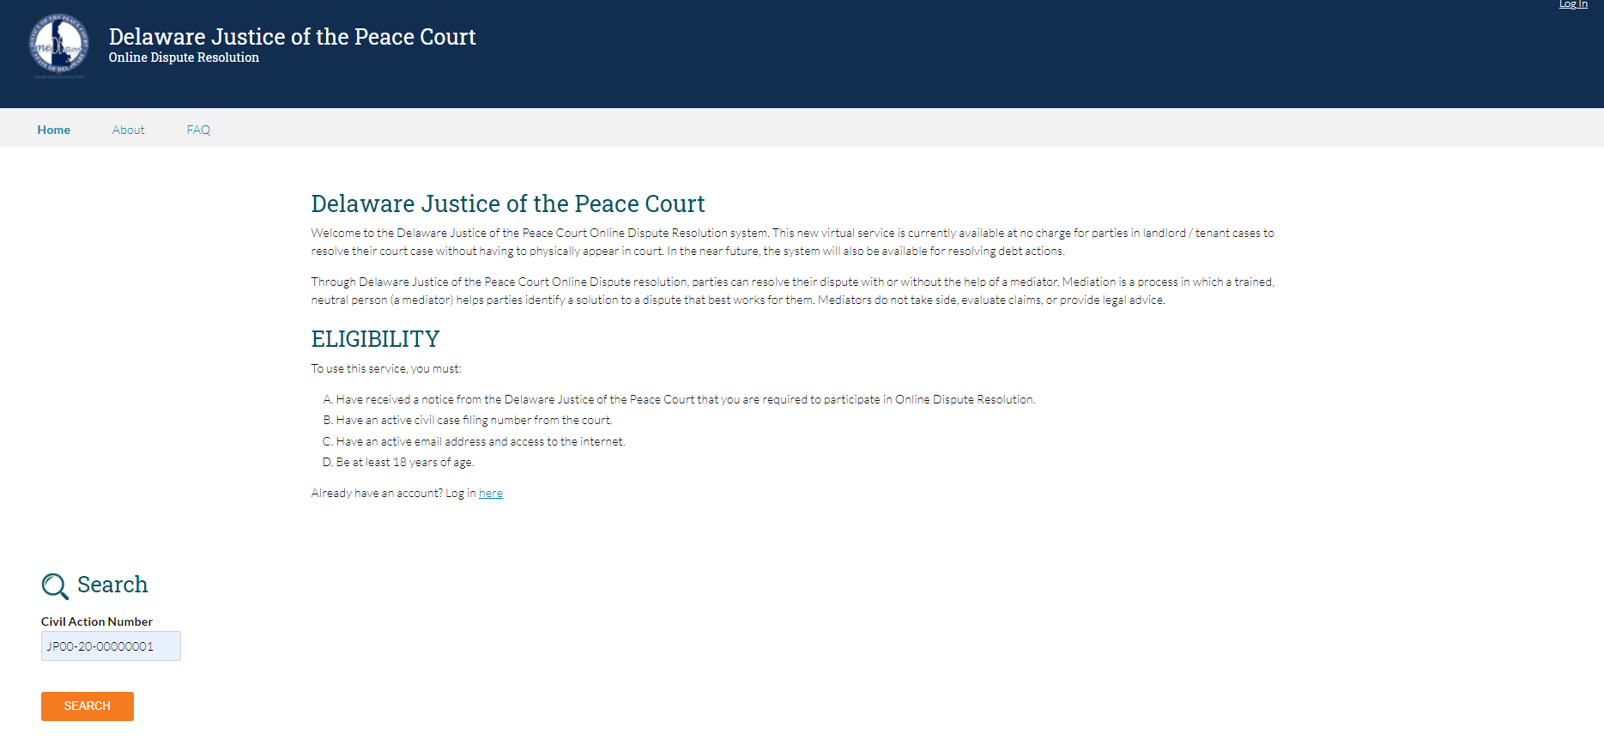

The system will match the searched Civil Action Number with the case in the database and allow the user to choose the party they wish to register.

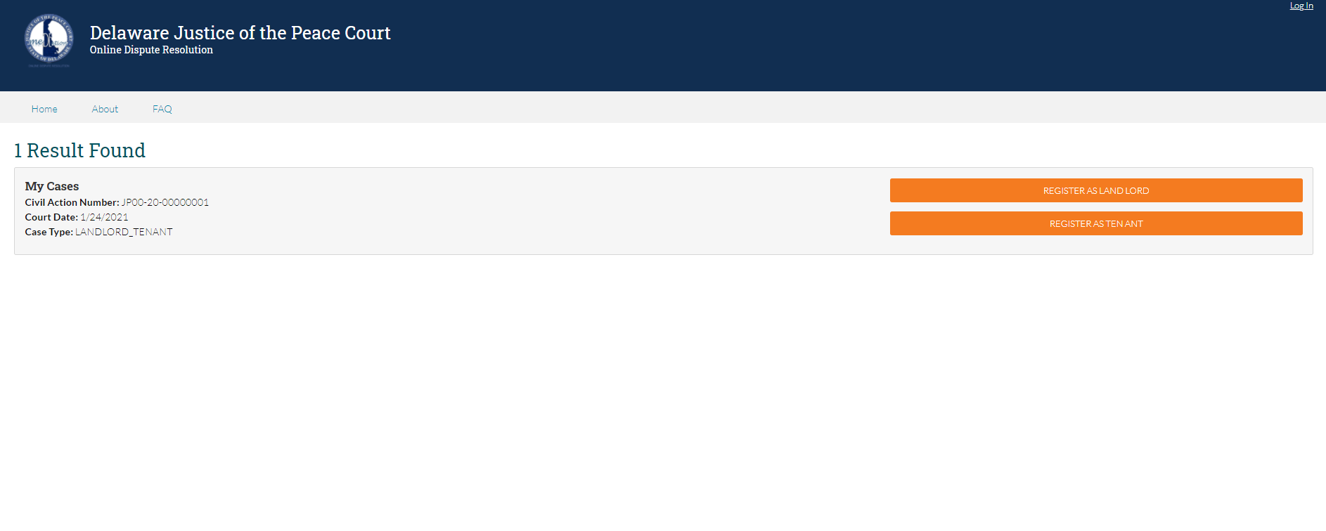

To complete the registration, parties will have to select their role in the proceeding (Landlord, Tenant, Neither). Parties must also be mindful to select the box if there is an active no contact order or Protection From Abuse order between any of the participating parties. Please note that selecting this box will prompt a mediator assignment immediately.

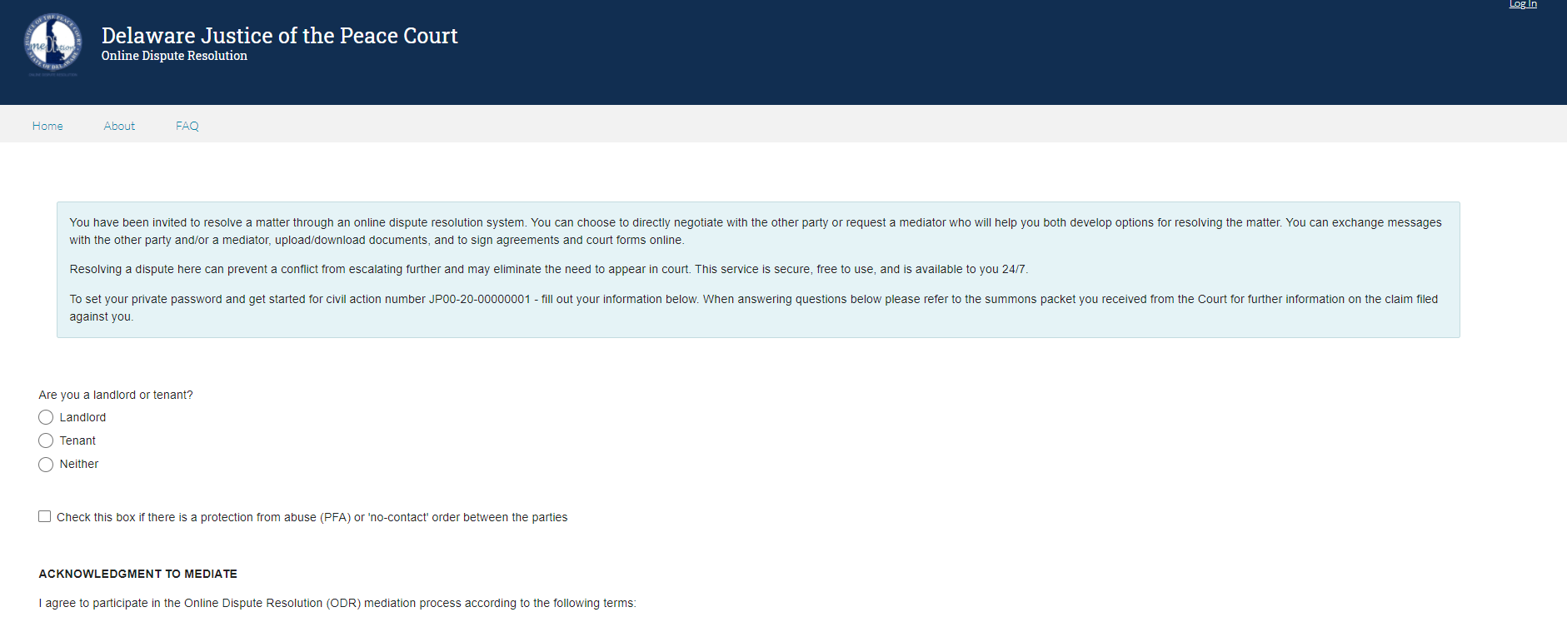
Selecting the role will populate additional questions that will have to be answered to complete the registration.

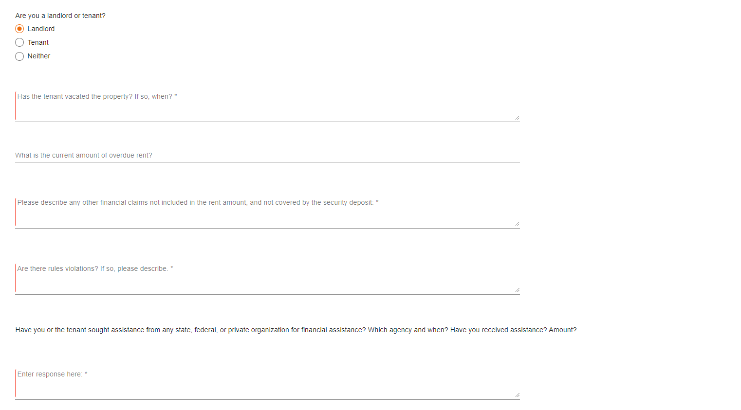

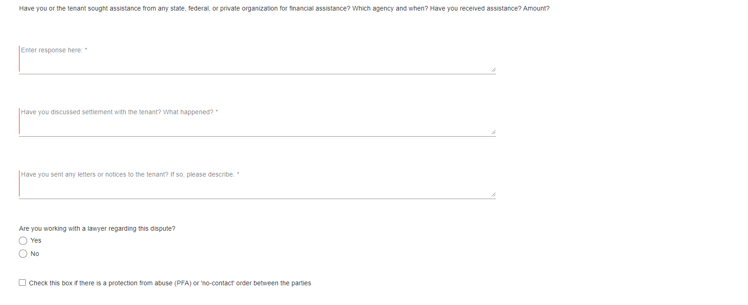

Parties will then read and acknowledge the process of the mediation.

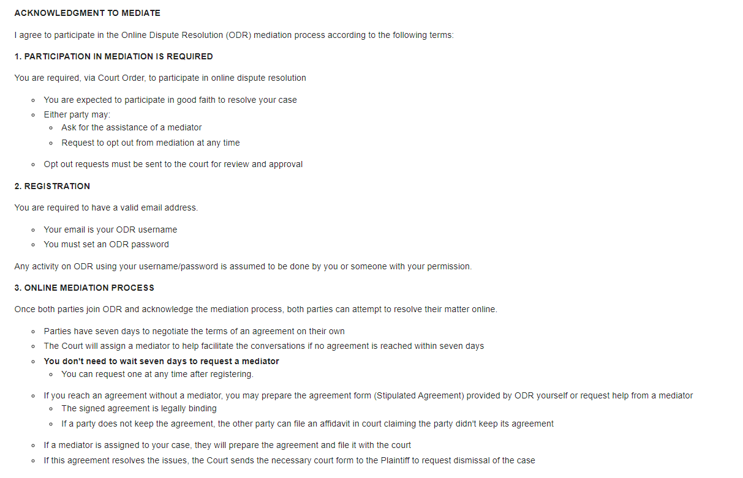

Parties will accept the Acknowledgment to Mediate by typing their name on the provided line

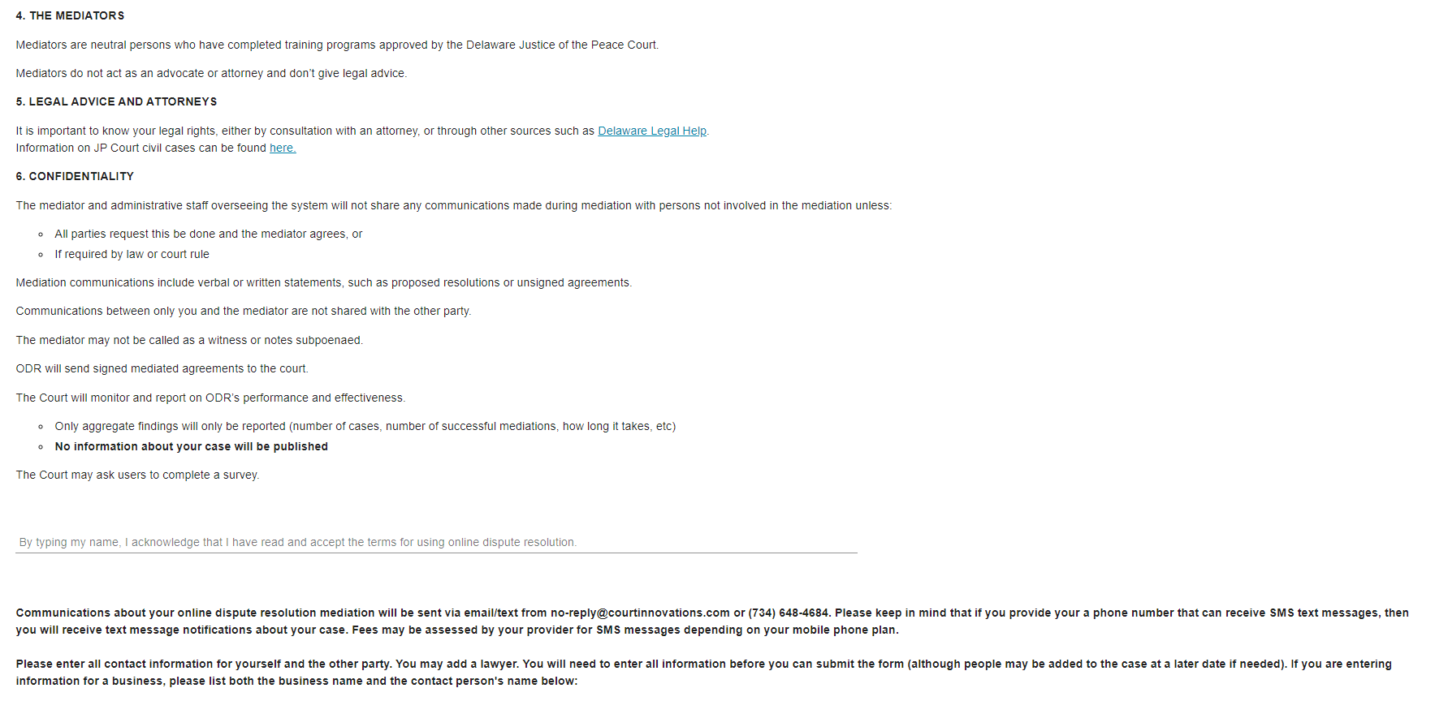

Parties can either register a new account or log in to a previously registered account. Please note, cellphone numbers that are entered into the system will receive updates and notifications regarding their case via SMS text messaging. Once the information is entered, parties will click the SUBMIT button to complete the registration and begin their case resolution
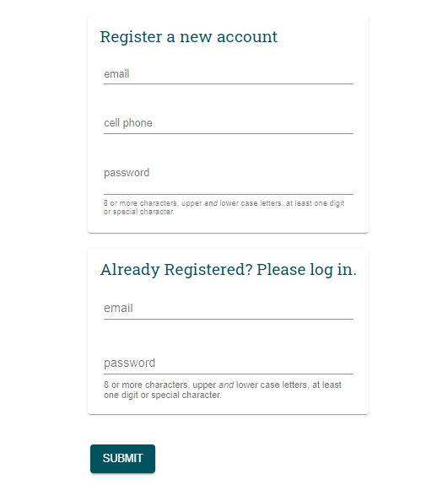

Registering and Logging in to the System (Debt Action)
When a case is added to the system, the party will receive an email (if email was provided at time case was filed) like the one below instructing the party to register, login and create a personal password. If email was not provided, parties can use their assigned case number to register on the website at https://cii2.courtinnovations.com/DEJPCOURT/court

The party will reference the court notice and input their Civil Action Number (case number) in the search box located on the home screen and press SEARCH

The system will match the searched Civil Action Number with the case in the database and allow the user to choose the party they wish to register.

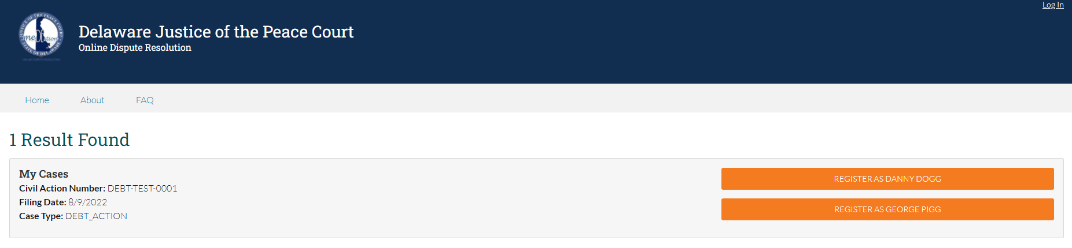

Once the party selects their name, they will be presented with the following screen.
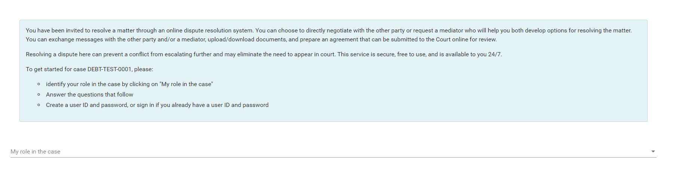

The first step is to define your role in the case. The available options are listed in the picture below. We will first discuss what happens when a PLAINTIFF registers their account.
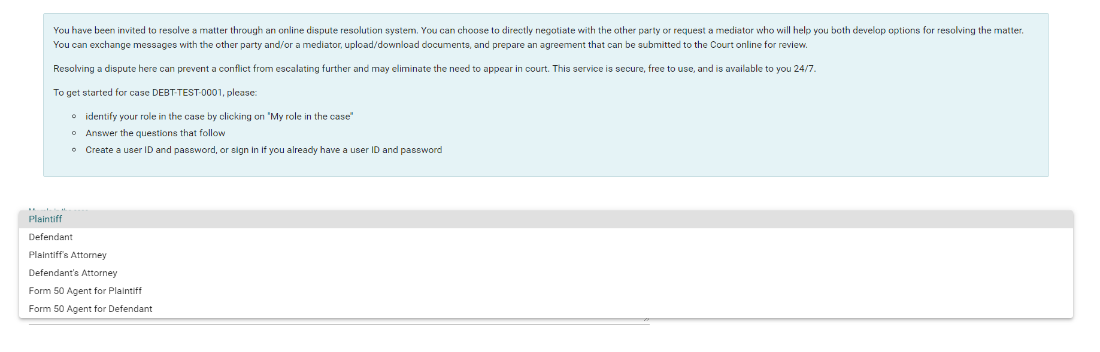

Selecting PLAINTIFF from the dropdown menu will present the questions in the graphic shown below. Plaintiffs will complete all of the requested information
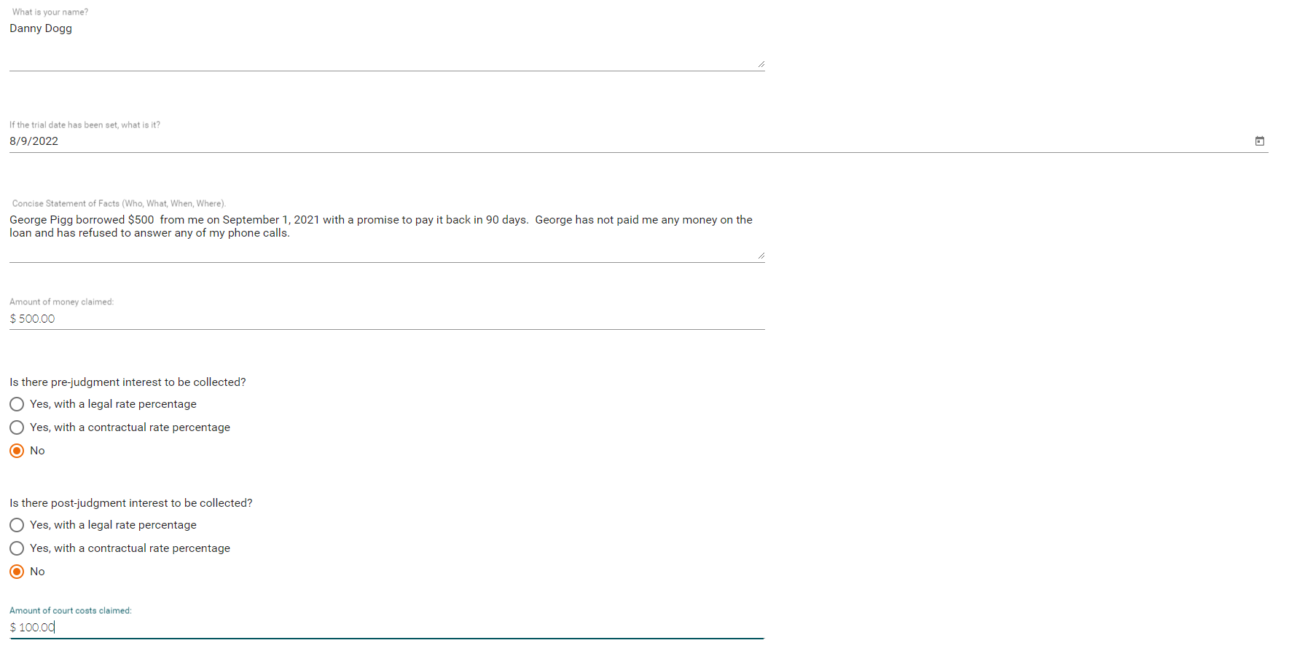

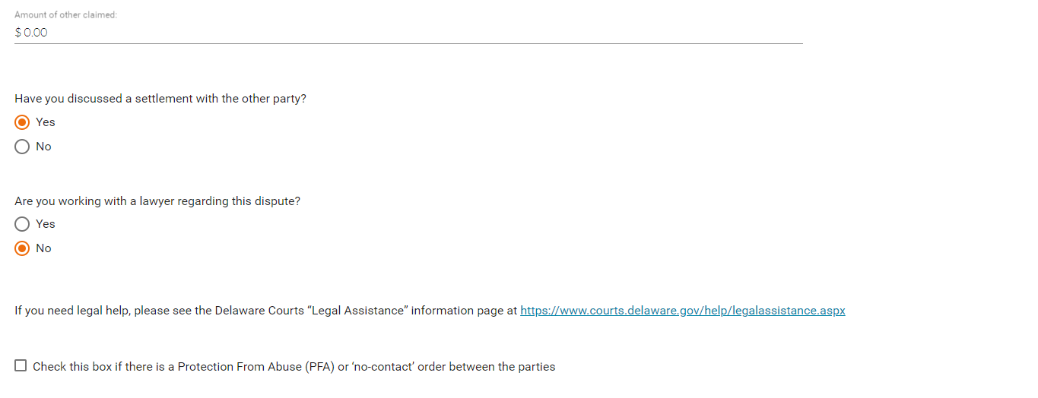

Plaintiffs will then read and acknowledge the process of the mediation.

Plaintiffs will accept the Acknowledgment to Mediate by typing their name on the provided line

Plaintiffs can either register a new account or log in to a previously registered account. Please note, cellphone numbers that are entered into the system will receive updates and notifications regarding their case via SMS text messaging. Once the information is entered, the party will click the SUBMIT button to complete the registration and begin their case resolution

Once they have either created their new account or logged into an existing account, the system will navigate them to their Case Display screen. The case details are displayed in the top left box, the parties are displayed in the bottom left box (blue check marks at the end of the names indicates whether or not the party is registered in the system for this case). The status of the case is displayed to the right of the detail boxes. This area also provides access to the Conversations and History tabs. In this example, the plaintiff is now registered and is awaiting the registration of the defendant.
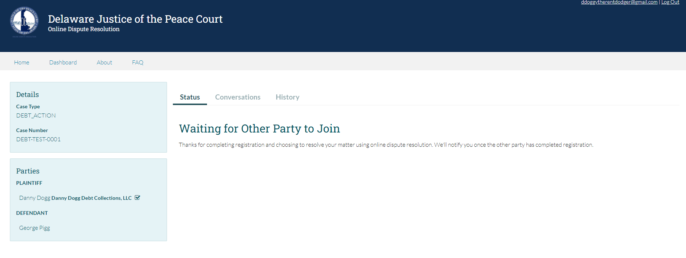

When the defendant begins the registration, they will select DEFENDANT from the dropdown menu

The defendant will then be presented with the following questions to answer in order to register their case. They will fill out the requested information and scroll down the page.
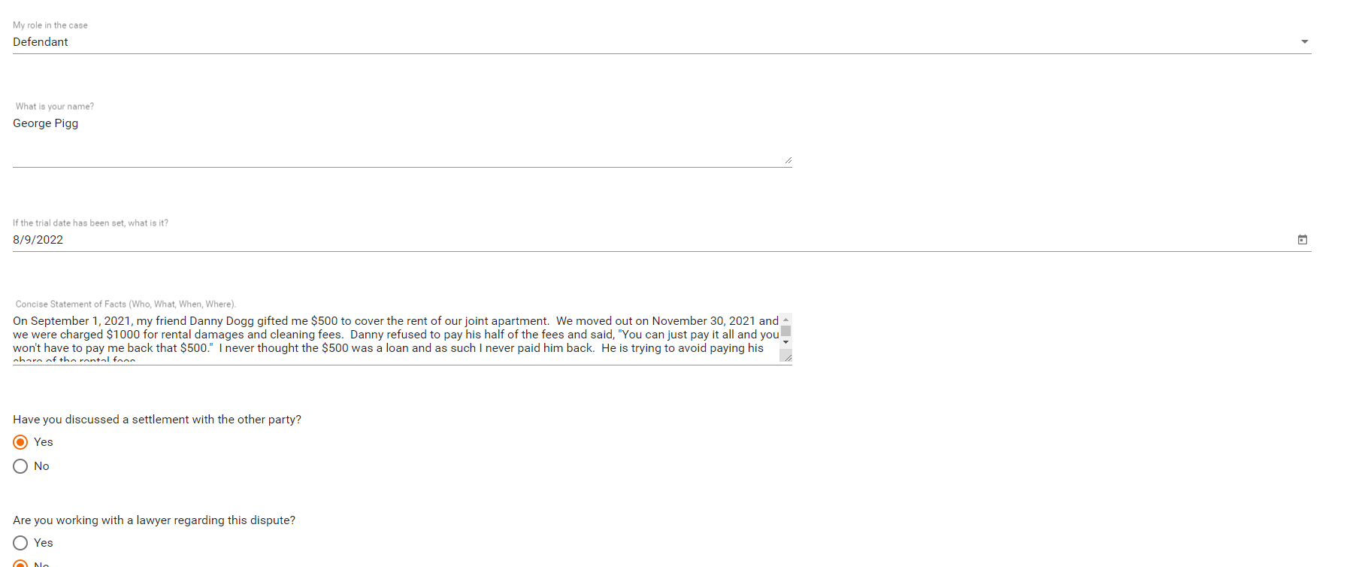

Defendant will then read and acknowledge the process of the mediation.

Defendant will accept the Acknowledgment to Mediate by typing their name on the provided line

Defendant can either register a new account or log in to a previously registered account. Please note, cellphone numbers that are entered into the system will receive updates and notifications regarding their case via SMS text messaging. Once the information is entered, party will click the SUBMIT button to complete the registration and begin their case resolution

Once the defendant and plaintiff are both registered they will see the screen below. This case is ready to begin the asynchronous communication in order to reach an agreement. Both parties are given the options of communicating and drafting their own agreement to be submitted through the system, request a mediator, add a defendant or opt out of the alternate dispute resolution system.
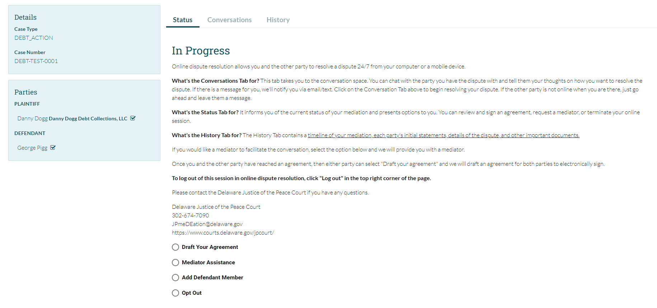

System Dashboard

The status screen will display the current status of the case and any options the user has available directly under the status and description. Parties can begin conversations by selecting the Conversations tab. Users can also view the history of the case by clicking the History tab.

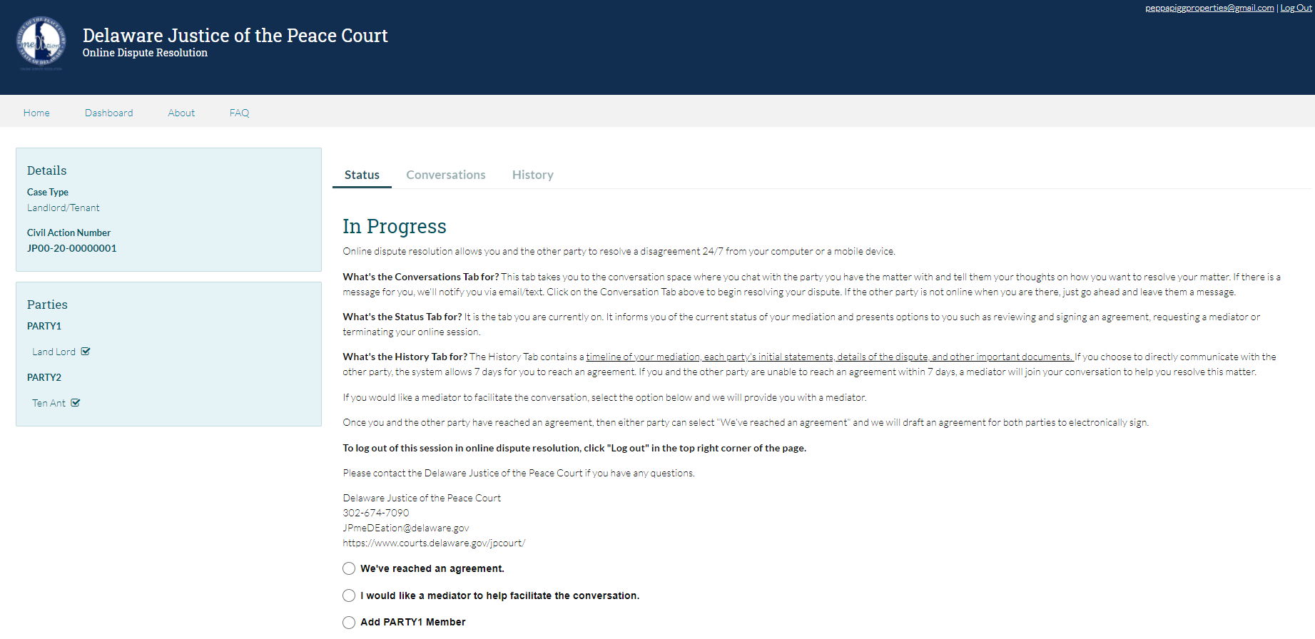

Using Conversations

Parties will send messages through the system by selecting the conversation tab and typing a message in the supplied block. Parties can also attach files to the conversations as well. If a mediator is involved in the case, an additional channel of conversations will appear to allow conversation between the individual parties and the mediator. The conversation between Party 1 and the mediator cannot be viewed by anyone other than Party 1 and the mediator. Likewise, conversations between Party 2 and the mediator can only be viewed by Party 2 and the assigned mediator.

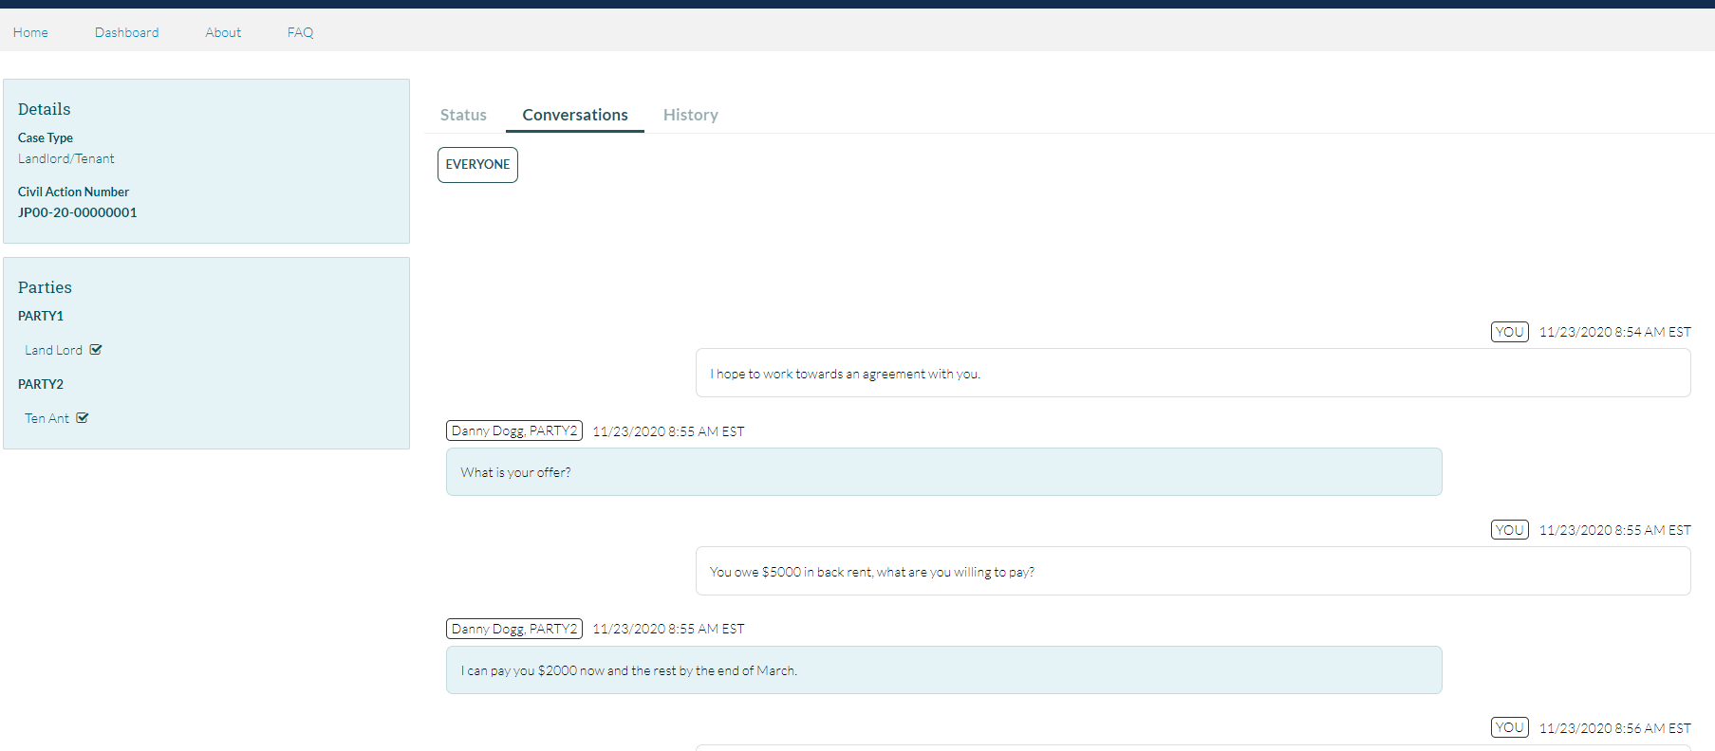

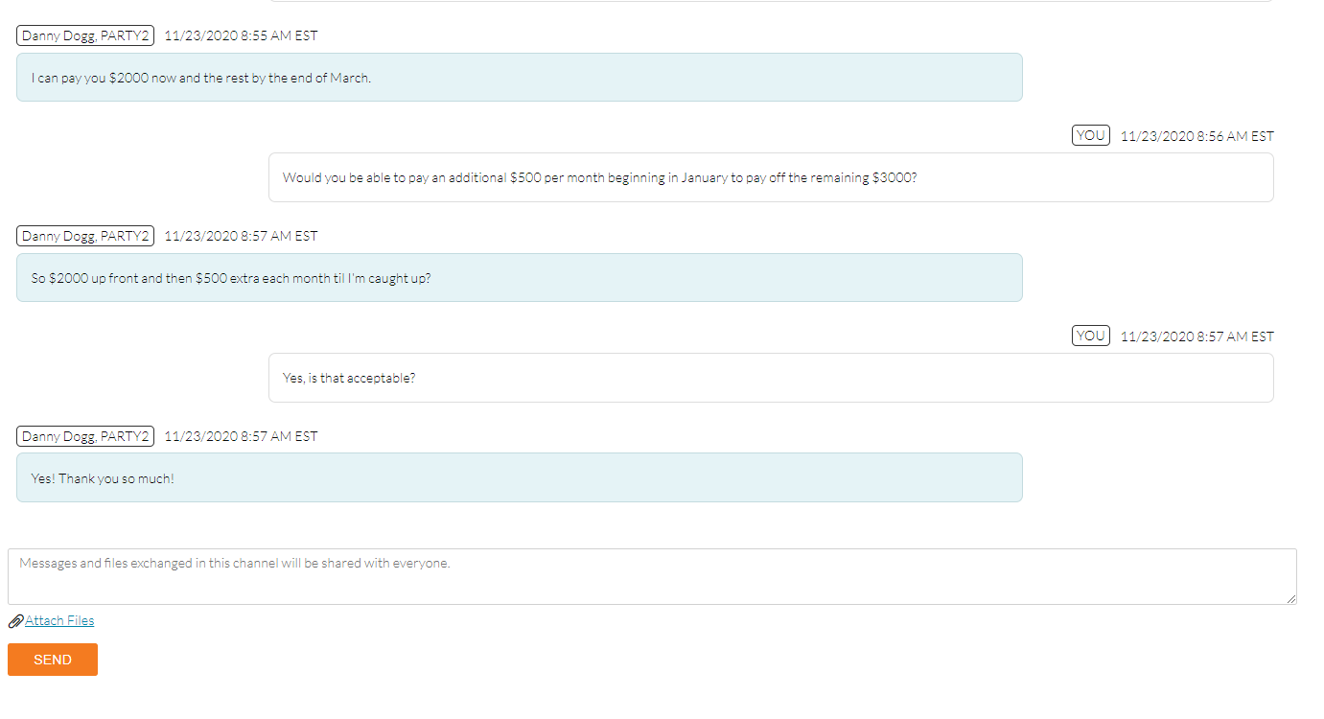

Adding another Person to your Party

In the event that a party would like to add another user to their party, they can invite them through the system. They will select the option for ADD PARTY# MEMBER (where # is the party number) and then enter their name and email address. Clicking SUBMIT will send the invitee an email from the system, allowing them to register and join the case in progress.

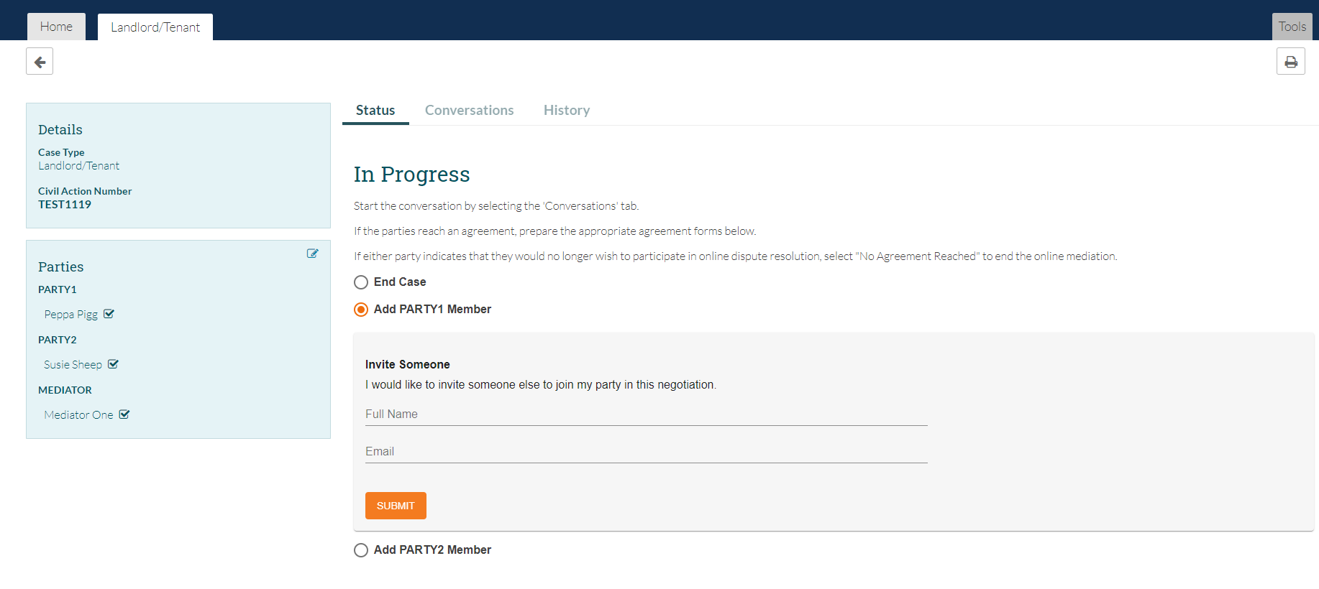

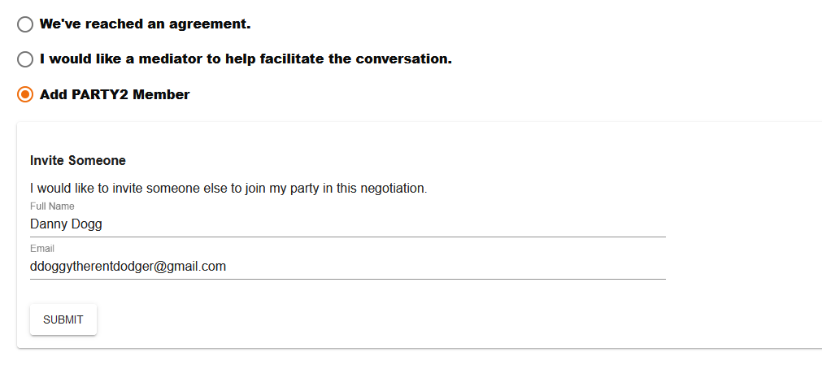

Requesting a Mediator to Assist

Parties can request assistance from a mediator by selecting the option from the Status screen and confirming their selection. The status will change to MEDIATOR REQUESTED and then once a mediator is assigned the status will change to MEDIATION IN PROGRESS. Please note, that both parties are given a set timeframe beginning at registration to reach an agreement. If no agreement is reached within that time, the system will prompt the Court to assign a mediator. Also, if an active No Contact Order or Protection From Abuse order was reported during registration, a mediator would have been assigned automatically from the onset of the case.

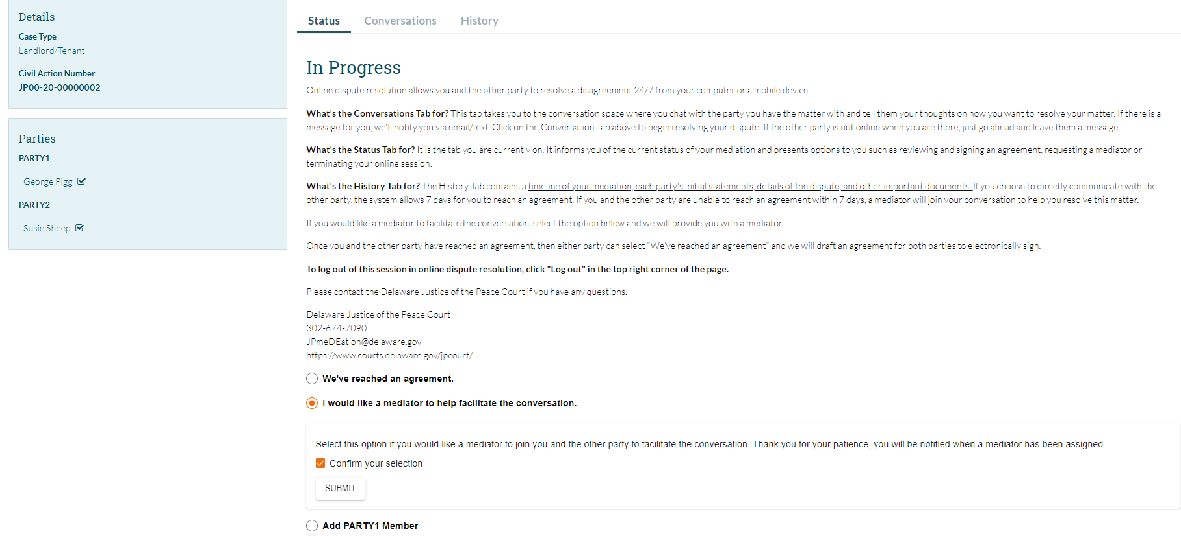

Completing the Stipulated Agreement

Once an agreement is reached, the user will utilize the embedded form generator in the system to draft the Stipulated Agreement. From the case detail screen, the user will click the button for PREPARE AGREEMENT which will open another section on the same page where the user will click the button for Stipulated Agreement and begin to input the appropriate data into the provided fields. When all of the appropriate information is complete, the user will click the STIPULATED AGREEMENT button at the bottom of the form generator to submit the form to the system.

Please see next pages for a visual aid of the screens.

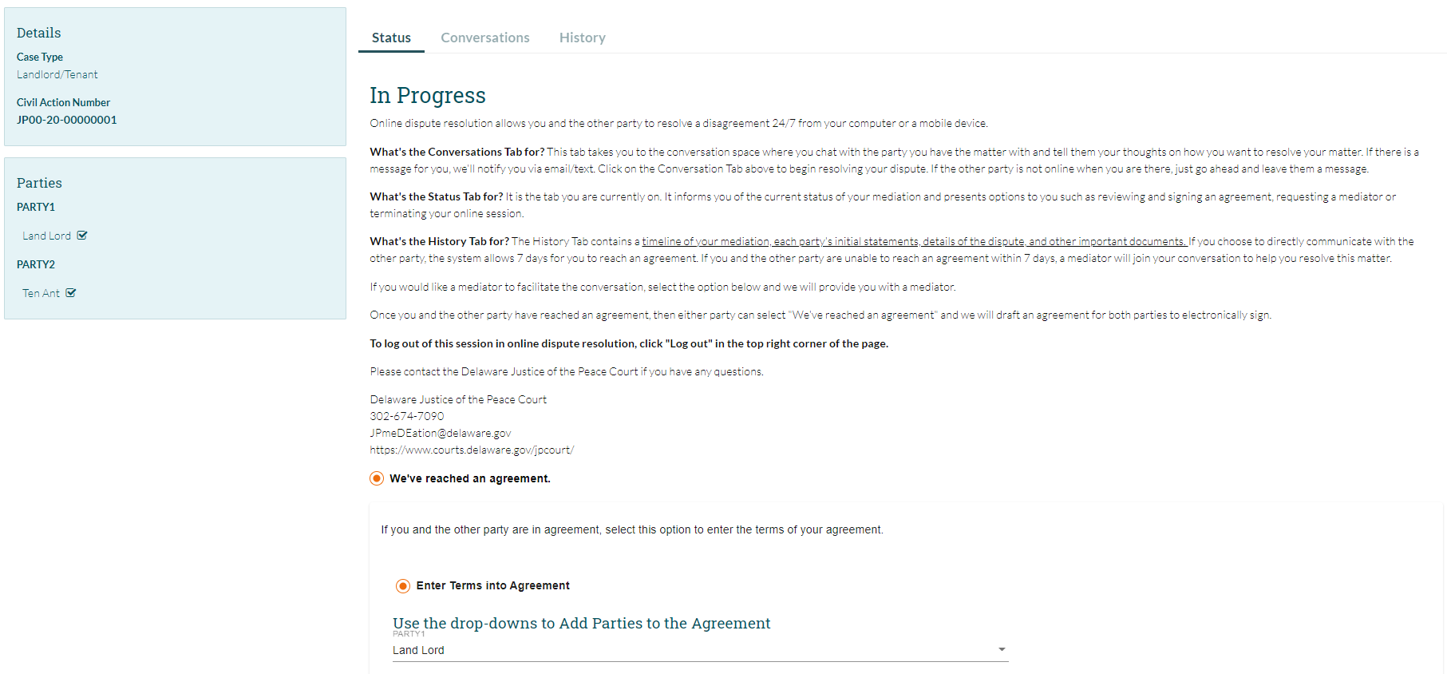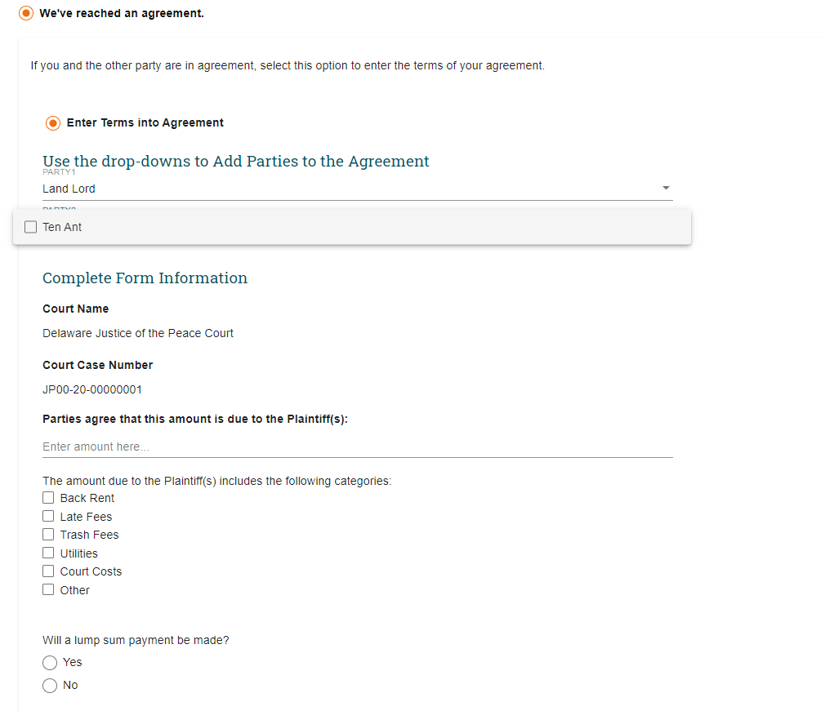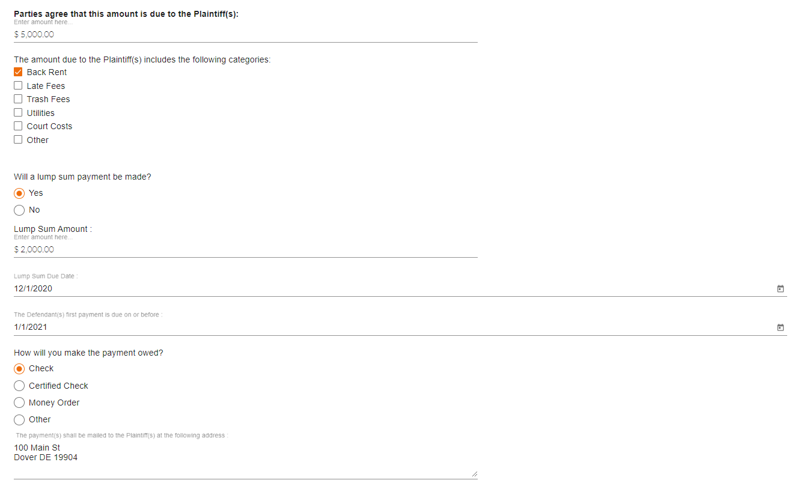

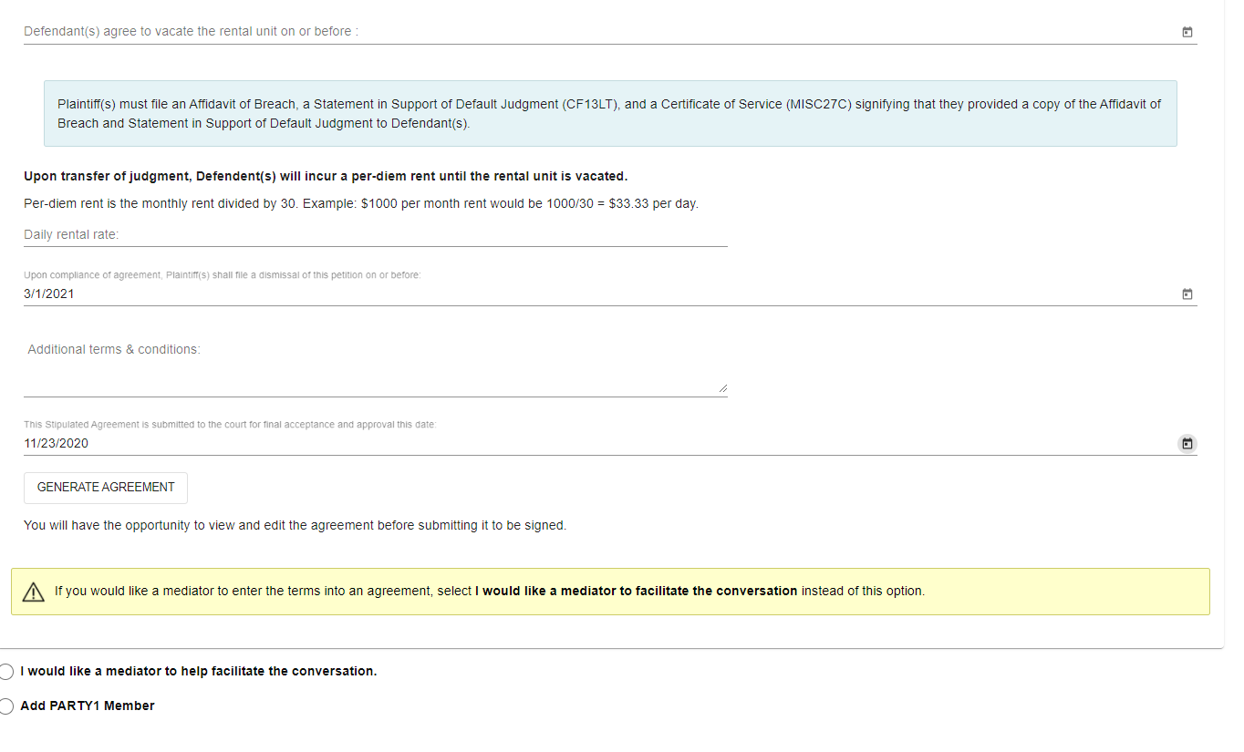

Once the form is submitted to the system, the user will have an opportunity to review and edit any information that was entered in the form generator. If all of the information appears correctly, the user will click the SAVE & SUBMIT FORM button to send the form to all involved parties for review and signature.

Please see next pages for a visual aid of the screens.
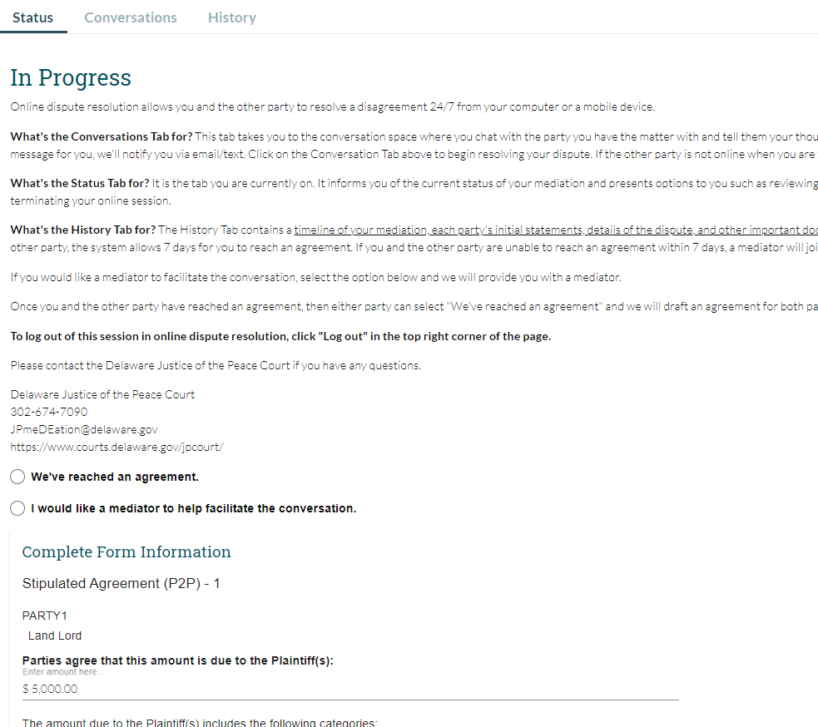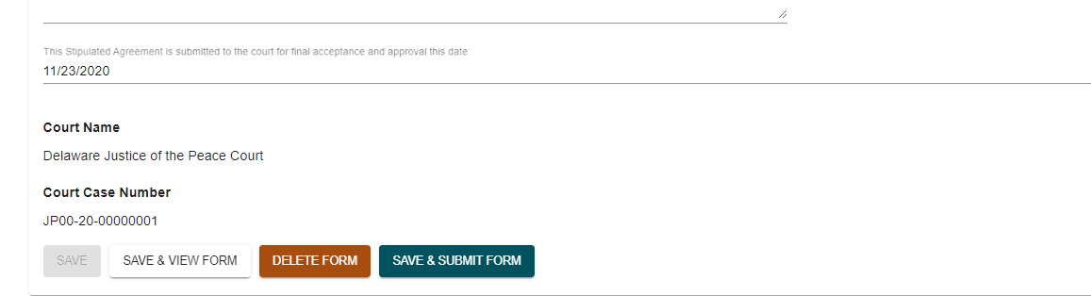

Once the user is notified that the agreement is available to be reviewed and signed, the user will review and sign the form to finalize and submit the form to the court for docketing. Note: If a party rejects the agreement, the party will have to indicate the reason for the rejection. Once the party submits the rejection, the parties will have the ability to make edits and resubmit the agreement to all parties. If a mediator is involved in the case, they will sign after the parties and submit the agreement to the court.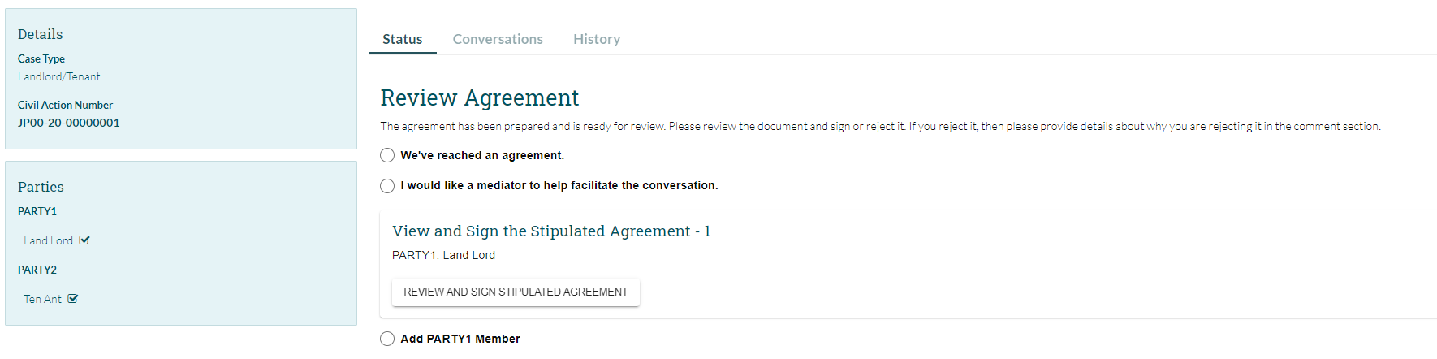

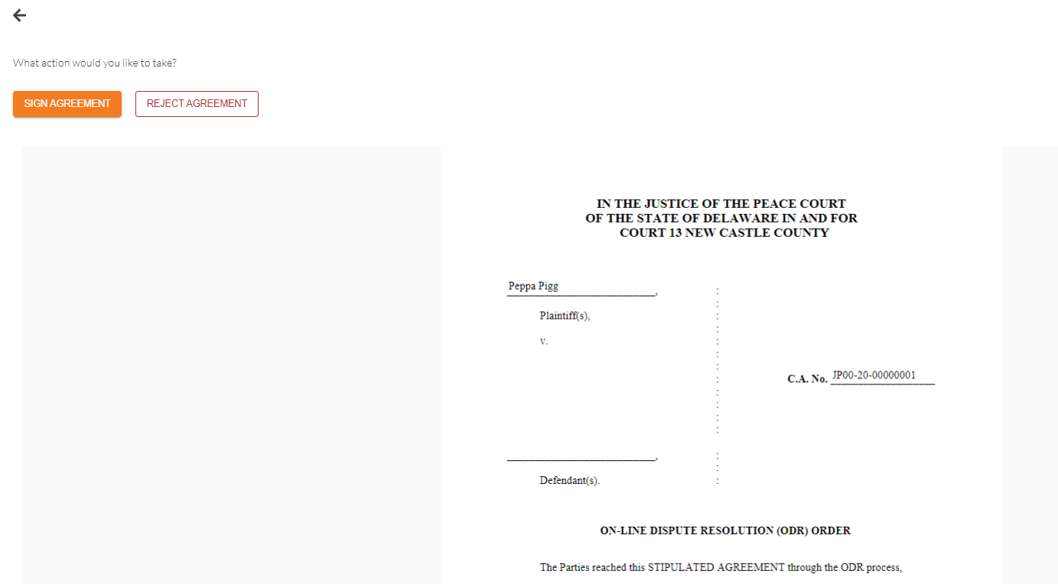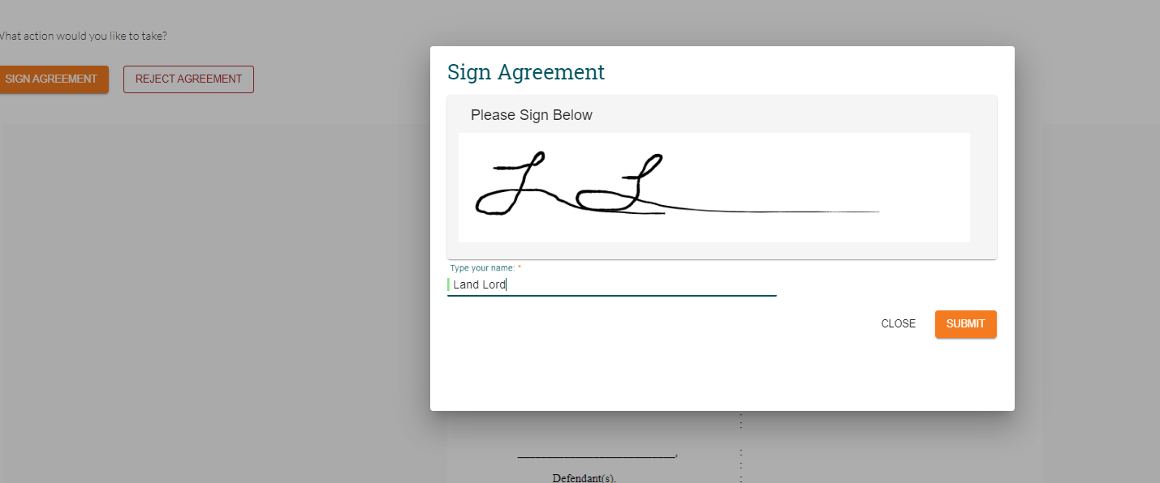

Submitting the Stipulated Agreement to the Court

Once all signatures have been affixed to the agreement, Party 1 will click the button for PARTIES REACHED AN AGREEMENT and enter the generic court email address along with any additional emails. Party 1 will click the drop-down arrow and select the Stipulated Agreement form, then click SUBMIT to send the completed form to the court for docketing.

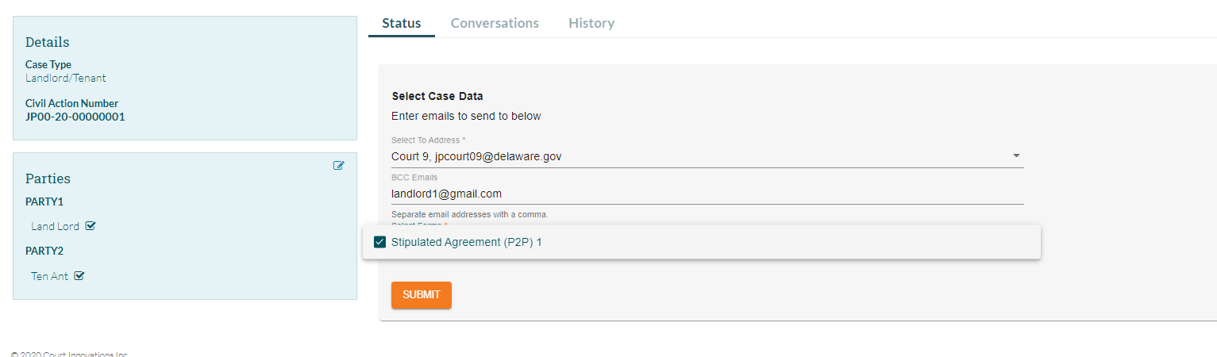

Appendices

Stipulated Agreement Example (double click to open full document)

Contact Information

Phone Number 302-674-7090
Email address jpmedeation@delaware.gov
Website https://courts.delaware.gov/jpcourt

Updating Account Information

Parties can update their account information by clicking their username in the top right-hand corner of any ODR screen

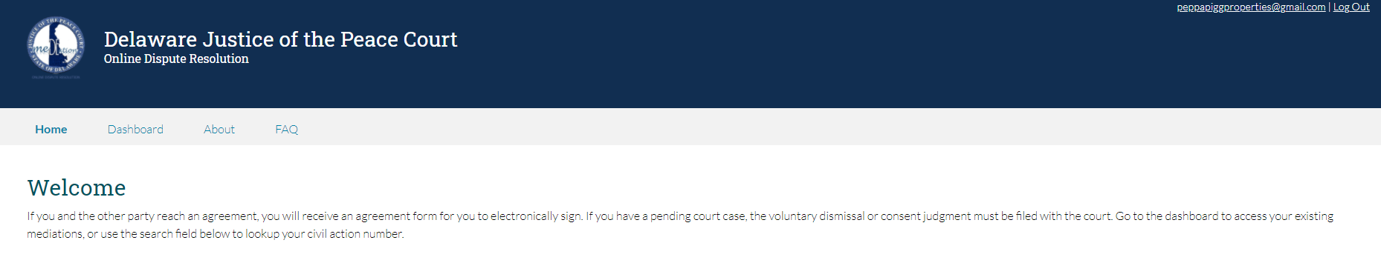

Parties can update their preferred email address and phone number by clicking either orange CHANGE button on their USER PROFILE screen. Clicking the CHANGE button next to PASSWORD will allow the party to update their system password.

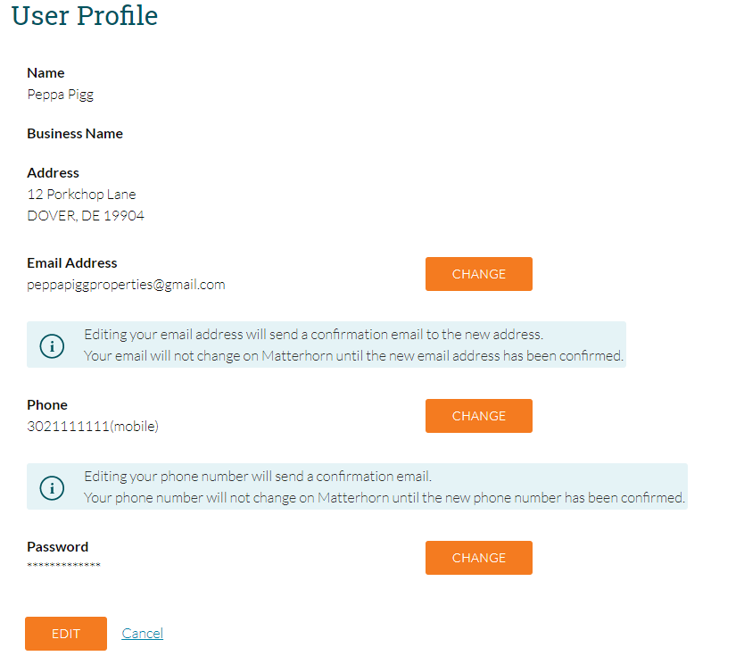

When parties edit either their email address or phone number, the window below will open allowing them to edit their name, email address, and phone number. Addresses must be updated by the court. Changes can be submitted by clicking SAVE at the bottom of the screen. Note: changing the email address or phone number will require verification. Upon verification of any email change, the party must use the NEW email address to log in to the system.

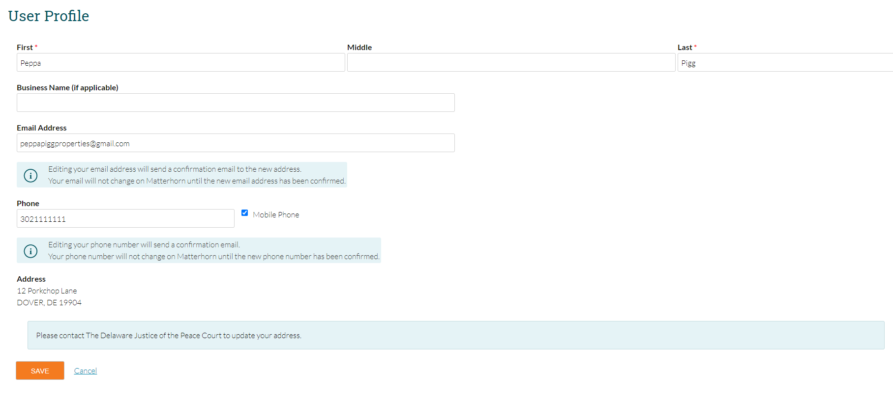

When parties edit their system password, they must enter their current password, new password, then the new password a second time to confirm the change. Changes are submitted by clicking the SUBMIT button.

