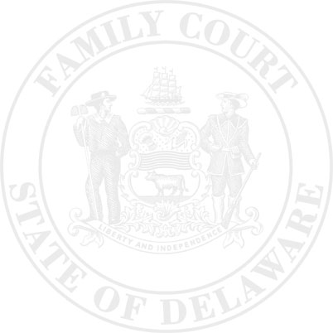
The Family Court of the State of Delaware
In and For New Castle Kent Sussex County
PETITION FOR CHILD SUPPORT MODIFICATION
Increase Decrease
DCSS #

Petitioner Respondent
^{Name} |  |  |  |  |  |  | ^{Name} |  |  |  |  |  |  |  | ^{File Number}
^{Street Address (including Apt)} |  |  |  |  |  |  | ^{Street Address (including Apt)}
^{P.O. Box Number} |  |  |  |  |  |  | ^{P.O. Box Number} |  |  |  |  |  |  |  | ^{Petition Number}
^{City/State/Zip Code} |  |  |  |  |  |  | ^{City/State/Zip Code}
^{Date of Birth} |  |  |  |  |  |  | ^{Date of Birth}
Attorne Attorney Name and Phone Number |  |  |  |  |  |  | A Attorney Name and Phone Number
Driver’s License #: |  |  |  | State: |  |  | Driver’s License #: |  |  |  |  | State:
Employer: |  |  |  |  |  |  | Employer:
Employer Address: |  |  |  |  |  |  | Employer Address:
^{Interpreter needed?} |  | Yes No |  |  |  |  | ^{Interpreter needed?} |  | Yes No
^{Language} |  |  |  |  |  |  | ^{Language}

in the interest of: (Include last name.)
Name DOB |  |  | Name DOB |  |  | Name DOB
Name DOB |  |  | Name DOB |  |  | Name DOB

The Petitioner seeks a modification of the Child Support Order dated |  | and alleges the following:

1. |  | More than 2 ½ years have passed since entry of the order in which current support was last determined.
2. |  | Less than 2 ½ years have passed since the last current support determination and a substantial change of circumstance, through no wrongful conduct of the Petitioner, has occurred regarding.
 |  | Income or deductions | Number of minor children on this Order to support
 |  | Health insurance cost or availability | Number of other minor children to support
 |  | Daycare or private school tuition | Other
Required for #2 – Describe exactly what changed since the above order:

Therefore, the Petitioner requests modification of the current child support Order in accord with recalculation pursuant to the Delaware Child Support Formula and acknowledges:
- If the petition was filed within 2 ½ years of the entry of the order in which current support was last determined, only modifications of greater than 10% will be imposed.
- Whenever a modification petition is filed, the ordered obligation may increase or decrease regardless of which party filed the petition.
- Loss of license and incarceration for nonpayment of child support are not grounds for child support modification.
- Summonses for modification petitions are sent by the court by regular mail. Therefore, any modification order entered on this petition may be made effective as of three (3) days after the posting of the summons.
- If I have not properly completed paragraph one (1) or two (2), my petition may be dismissed.

Petitioner/Attorney Print |  | Petitioner/Attorney Signature |  | Date

