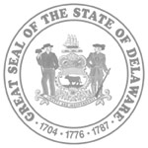
JUSTICE OF THE PEACE COURT
SPEAKER REQUEST FORM

Please complete this form to request a speaker from the Justice of the Peace Court’s Speaker’s Bureau.

Name of Organization:

Address:

Contact Person:

Telephone Number:

Email address:

Date of Meeting (First Choice):

Additional Meeting Dates:

Location of Meeting:
(to include address)

Speaking Topic:

Thank you for your interest in a speaker from the Justice of the Peace Court. We will be in contact with you to confirm your request.

Mailing Address: Chief Magistrate’s Office, 5 East Pine Street, Georgetown, DE 19947
Fax: 302-856-5919

