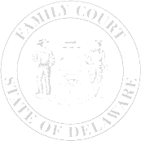
The Family Court of the State of Delaware
In and For New Castle County Kent County Sussex County

WAIVER OF TIME TO CONTEST DIVORCE HEARING

Petitioner |  |  | v. |  |  | Respondent
Name |  |  |  |  | Name
 |  |  |  |  |  |  |  |  |  | File Number
Street Address |  |  |  |  | Street Address
Apt. or P.O. Box Number |  |  |  |  | Apt. or P.O. Box Number
 |  |  |  |  |  |  |  |  |  | Petition Number
City | State | ZIP Code |  |  | City |  | State | ZIP Code
Attorney Name and Phone Number |  |  |  |  | Attorney Name and Phone Number

I, |  |  | , Respondent, do hereby waive the 20 day
period in which to contest, answer, or otherwise plead in regard to the captioned divorce filed on
 |  | .

 | Respondent Print Name |  | Respondent Signature

SWORN TO AND SUBSCRIBED
before me this date,
Date |  | Clerk of Court/Notary Public

