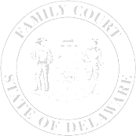
The Family Court of the State of Delaware
In and For New Castle County Kent County Sussex County

AFFIDAVIT OF GOOD CAUSE

)
)
)
)
)
)

 | ,
Petitioner |  |  | File No.:
v.
 |  |  | Petition No.:
 | ,
Respondent

I hereby swear/affirm that the following statements are true:
1. | The claims, which I am seeking to litigate, have never been raised or disposed of before
 | in any court.
2. | The facts alleged are true and correct.
3. | I have made a diligent and good faith effort to determine the law with regard to the
 | issues I have raised.
4. | I have no reason to believe that the claims I am raising are foreclosed by the law.
5. | The claims are not malicious in that they are not designed to vex, injure or harass the
 | opposing party, or abuse the judicial process.
I swear or affirm that the information in this affidavit is true and correct and made under penalty of perjury.

Print Name of Filing Party |  |  |  | Filing Party’s Signature
 | County
Sworn to and subscribed before me this |  |  |  |  | day of |  | , |  | .
 |  | Notary Public

