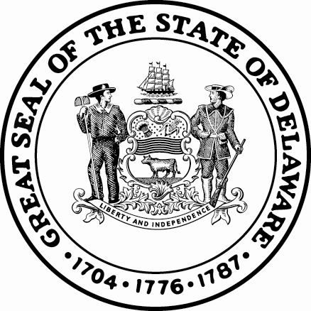

State of Delaware

Office of State Court Collections

414 Federal St, Rm 175

Dover, DE 19901

(302) 739-1980

Assignment of Wages

Case Number
Case Number

Employer:

Company Name
Company Street Address
City, State Zip
Attn: Payroll Dept.
RE: Employee (Defendant): Def Name
Social Security Number: Def SSN

To Whom it May Concern:

The subject employee is indebted to the State of Delaware in the sum of $Total Monies Owed for fines, court costs and/or restitution. At the bottom of this form is an executed authorization by the employee for the deductions from the employee’s wages.
You are therefore directed, under the provision of 11 Del. Code §4104c, to withhold $Weekly deduction weekly from the wages of Def Name (Employee) until the total sum of $Total Monies Owed has been deducted. Please forward that amount on a weekly, biweekly or monthly basis to the “State of Delaware” at one of the above referenced locations.

11 Del. Code §4104c also provides that an employer shall take no action against an employee who has executed an assignment of wages, and that the employer may not penalize that employee solely because of the assignment.

Voluntary Assignment of Wages

I Def Name, do hereby agree to make payments to the State of Delaware, Office of State Court Collections Enforcement in the amount of $Weekly deduction weekly beginning 5/14/2024 on account(s) # CRA # until the account(s) is/are paid in full.
Defendant Name: Def Name
Defendant Address: Def Street Name
City, State Zip
Defendant Phone #: Home Phone
Date: 5/14/2024 Defendant Signature:

Attention: Payments are due on a regular basis. If payments are not received, a Contempt of Court Hearing will be scheduled immediately. Should the individual leave your employ, or you require any additional information, please contact the above referenced Office of State Court Collections Enforcement.
CC: Prothonotary
Revised: 10/15/15

