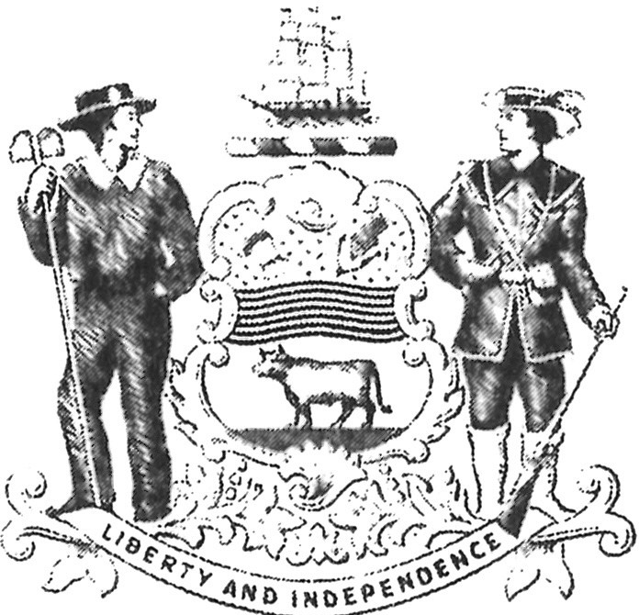
Office of State Court Collections Office Locations:

Northern New Castle Office 314 Cherry Lane
New Castle, DE 19720
(302) 577-1266
Central Collections Office 38 The Green, Room 176
Dover, DE 19901
(302) 739-1980
New Castle County Court House
500 N. King St
Wilmington, DE 19801
(302) 255-0468
Georgetown Courthouse Annex 5 East Pine St
Georgetown, DE 19947
(302) 856-5805

PAYMENT AGREEMENT
It is hereby acknowledged by the undersigned that all fine, costs, surcharges and restitution must be paid to the OFFICE OF STATE COURT COLLECTIONS ENFORCEMENT in cash, money order or check made payable to the State of Delaware in the amounts and at the times specified by the Court, or this Payment Agreement.
Payments can now be made through the OSCCE Payment Kiosks located at all Probation & Parole Offices!
To pay through the Web, please visit our website at http://courts.delaware.gov/AOC/OSCCE
Personal checks must include a telephone number and current address. THERE WILL BE A $30.00 FEE FOR ALL RETURNED CHECKS.
It is also acknowledged and understood that failure to abide by the specific court orders or a breach of this agreement shall be sufficient cause for a "Contempt of Court Hearing."

Judge: Case#(s):
Defendant Name: SSN# DOB:

Defendant Address:

City: State: Zip:
Home Phone:

Employer:

Employer Address:

City: State: Zip:
Work Phone:

Payment Schedule: $ Per Month beginning .
Total/Current Balance Owed: $ .

**FAILURE TO COMPLY WITH THIS MONTHLY PAYMENT AGREEMENT SHALL RESULT IN A CONTEMPT OF COURT HEARING**

(Defendant Signature) Date (Collection Officer Signature Date

White-OSCCE; Yellow-Defendant
Revised 7/10/12 D.C.I. Form#: SA-466

