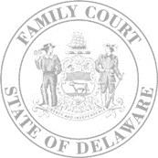
The Family Court of the State of Delaware
In and For New Castle Kent Sussex County

IN RE THE MATTER OF: |  | )  )  )  )  )  )  )  )
 |  | )  )  )  )  )  )  )  ) | File No.:
(CHILD’S NAME) |  | )  )  )  )  )  )  )  )
 |  | )  )  )  )  )  )  )  ) | Petition No.:
(DATE OF BIRTH) |  | )  )  )  )  )  )  )  )

WAIVER OF NOTICE

I, |  | the
 | (NAME OF PARTY WAIVING NOTICE) |  |  | (RELATIONSHIP TO CHILD)
of |  |  |  |  | understand that a hearing will take place in
 | (CHILD’S NAME)
the Family Court to consider a Petition for Termination of Parental Rights in my above-named child. In compliance with Section 1106A of Title 13 of the Delaware Code, I hereby waive my right to any and all notice of such hearing.

Party Waiving Notice

Sworn to subscribed before me this |  |  | day of |  |  |  | ,
 | Clerk of Court/ Notary Public |  |  |  |  | Date

