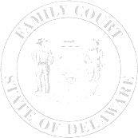
The Family Court of the State of Delaware
In and For New Castle County Kent County Sussex County

 | , | )  )  )  )  )  )  )  )  ) | File No.:
Petitioner |  | )  )  )  )  )  )  )  )  ) | File No.:
v. |  | )  )  )  )  )  )  )  )  ) | Petition No.:
 | , | )  )  )  )  )  )  )  )  ) | Petition No.:
Respondent |  | )  )  )  )  )  )  )  )  )

PERMANENT GUARDIANSHIP ORDER OF REFERENCE

Having considered the request of the movant,

IT IS SO ORDERED, this date:

The foregoing Petition for Permanent Guardianship having been presented to the Court, and it appearing that the Petition has been properly filed;

It is ordered that the
perform a Social Study and submit a report to the Court as required by 13 Del. C. § 2354.

Judge/Commissioner

