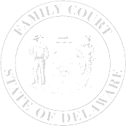
The Family Court of the State of Delaware
In and For New Castle County Kent County Sussex County

ATTORNEY ELECTION FORM – ELECTRONIC ORDERS

Attorney Name
Firm Name
Office Address
Office Phone
Cell Phone
Bar ID Number

I authorize Family Court to deliver court orders in my civil case(s) to my email address in an encrypted
email instead of to my mailing address. I understand that by providing my email address on this form,
all orders in my pending civil cases in Family Court will be sent to my email address encrypted by
Egress and will not be mailed to my physical address.
For more information on how to receive an encrypted email through Egress, please visit
https://judicial.state.de.us/courtdox/Download.aspx?id=94888&court=readonly.

I withdraw my authorization for Family Court to send court orders to my email address rather than my
physical address. I understand that by withdrawing this authorization I will only receive court orders at
my physical address and not my email address.

I wish to continue receiving court orders by email at a new email address.

Email Address:

Signature |  | Printed Name

Date

