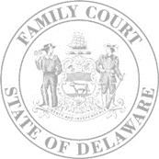
The Family Court of the State of Delaware
In and For New Castle County Kent County Sussex County

In the Matter of: |  | )  )  )  )  )  )  )  )
 |  | )  )  )  )  )  )  )  ) | File No.:
Date of Birth |  | )  )  )  )  )  )  )  )
Male Female |  | )  )  )  )  )  )  )  )

FINAL ORDER OF ADOPTION

 | And now, this |  |  |  | day of |  |  | it appearing that
 |  |  |  |  |  |  |  |  | has petitioned the Court to be allowed to
 | adopt as his/her/their own child,
 | born on |  |  |  |  | .

The records indicate that all statutory requirements have been met;

An investigation has been conducted pursuant to an Order of Reference signed by this Judge.

The Court is satisfied as to the fitness of Petitioner(s) to maintain, care for, and educate the child(ren) and child’s or children’s best interest will be promoted by the proposed Adoption.

 | It is ordered that
 | shall be the child(ren) of |  |  |  |  |  | for all legal
 | Intents and purposes, and the child or children shall henceforth be known as
 |  |  |  |  | .

Judge

